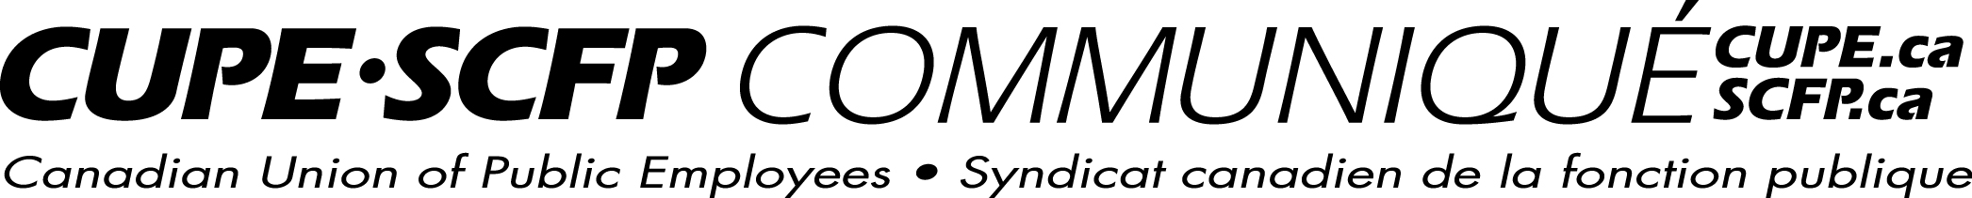
For immediate release | May 22, 2015

P3 NURSING HOME NOT THE SOLUTION

MIRAMICHI: The Liberal government’s decision to use a public-private-partnership (P3) financing model for the construction of a new nursing home in Miramichi is the wrong decision.

“Across the country, we have seen many examples where public-private-partnerships have gone south. Auditor Generals from across the country, including New Brunswick, gave P3 projects bad reviews. Public-private-partnerships cost more”, said the president of the New Brunswick Council of Nursing Homes Unions, Wayne Brown.

“If there is one sector where the government should not wash its hands from its responsibilities, it is the long term care. If this Government is committed to making life better for our seniors, then it should not go down the P3 path.”

“Under the P3 model, a private sector proponent is responsible to design, build, finance, own and operate the nursing home. The government is shifting the financial liability for construction, cost overruns and ongoing maintenance to the private sector. A public-private-partnership is more than that. We have an example at the Evergreen School in Moncton, which was done as a P3 model. Every time the community wants to use the school after hours, it needs to pay. It’s not free anymore, so the kids now use other public schools for their extracurricular activities. They’ve lost the ownership of their school.”

“In a P3 nursing home, how much will a family have to pay to use a room to host a Christmas dinner or to celebrate a birthday? The community will lose the ownership of their nursing home.”

“We know Miramichi is in need of a new nursing home, but we believe the community and the seniors will be better served if the nursing home is built as a not-for-profit home. We are calling upon the Government to establish a provincial strategy for public long term care facilities”, concluded Brown.

For more information:
Wayne Brown
NBCNHU 866-9105

Pat Roy
CUPE representative 684-0088
mlp/cope491

